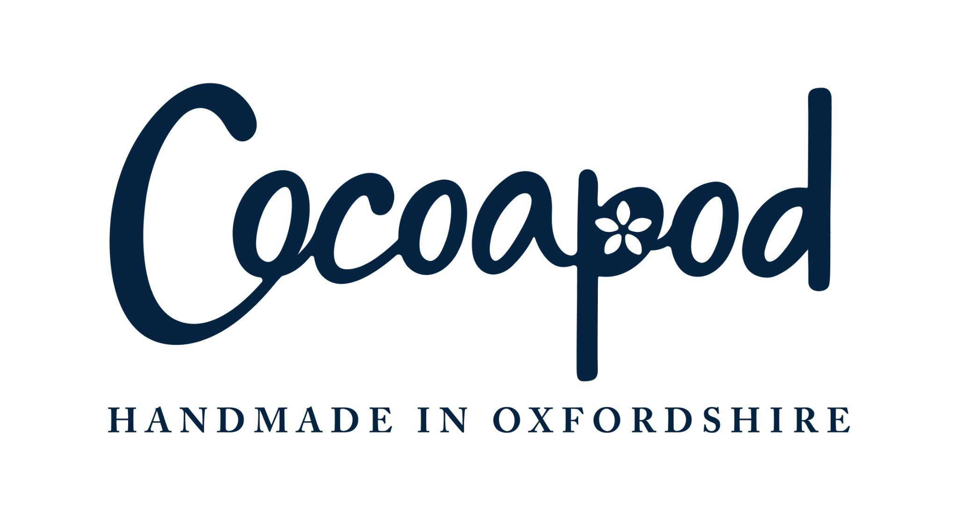
- Our chocolate is free of WHEAT, GLUTEN, NUTS, SESAME, and EGGS. However, we must inform our customers that traces of these allergens may be present in the final product due to shared equipment and processing areas.
- For allergens see ingredients in BOLD CAPITALS.
- Colours marked with a * may have an adverse effect on activity and attention in children.

Chocolate Ingredients

MILK Chocolate Ingredients:
Sugar, cocoa butter, whole MILK powder, cocoa mass, emulsifier: SOYA lecithin, natural vanilla. MILK chocolate min. cocoa solids 33% & min. MILK solids 21%.

White Chocolate Ingredients:
sugar, cocoa butter, whole MILK powder, emulsifier: SOYA lecithin; natural vanilla flavouring. White chocolate Min. cocoa solids 28% & min. MILK solids 23%

Halloween Patterns:

Skulls and Roses Ingredients:
Sugar, Vegetable Fat (Source: Palm) Colour E100, Vegetable Fat (Palm, Shea) Colour E171, E172, E120, E162, Emulsifier SOYA Lecithin, Glucose syrup, Colour E133.

Spiders Ingredients:
Fat reduced cocoa powder, acidity regulator: E524, E501i, Vegetable fat (Palm, Shea)

Creepy Forest:
Sugar, Vegetable Fat (Palm) Colour E162, Colour E171, Colour E172, SOYA Lecithin

Ravens Ingredients:
Sugar, Vegetable fat (Palm) Safflower Powder (maltodex-trin, safflower extract) Colour E171, E162, E172, Emulsifier: SOYA Lecithin

